Md. Rafiqul Islam
ID: 191-33-822
Department of Electrical & Electronic Engineering, EEE-29, 2nd Semester, Section- PC (A)
Sir, I want to establish Face recognition technology, Artificial intelligence technology, Robotics in BD.
I have 2 years experience in Computer Servicing and all kind of IT and electrical related problem. Here is the shop (link) on google map where I worked last 2 years
https://www.google.com.bd/maps/place/Trust+Computer+Services/@23.9890347,90.3835084,19z/data=!4m5!3m4!1s0x0:0x4b92812fa44b3647!8m2!3d23.9893725!4d90.3831261?hl=en&authuser=0
I working hard on my electrical project. I have some extremely valuable idea. I repeat I have some #extremely_valuable idea. I know what is right now trending IT product in BD. Sir, I am an EEE student and I have experience in Computer Servicing and all kind of IT and electrical related problem.
Just remember if I have got attention to our chairman Sir and our senior teachers then I can Express my #extremely_valuable idea and Business trend. And I have a business Identity on Elephant Road. I have a good relationship with every Computer importer like Smart, UCC, Global, Golden and giant computer business institute like Startech, Rayens, Newaz Enterprise
I want to share my Idea. I want to speak to our chairman Sir and our senior teachers.
This not my Idea.
I am trying got some attention to our chairman Sir. Please show this message to our chairman Sir because he understands everything that I said. Reson why he understands because he Is the first person who invented the computer in BD. My father said he is a Load of Businessman in BD. He is a successful businessman because he chooses the IT sector. And remember one thing Every billionaire businessman in the world they are everyone doing IT related work like
Bill Gates- Microsoft Corporation
Mark Zuckerberg- Facebook
Jeff Bezos- Amazon.com
Ren Zhengfei- Huawei Investment & Holding Co., Ltd.

Please, Show this message to our chairman Sir
And I have some skill
1. Graphic designer
2. Computer servicing engineer
3. Work Under High Pressure
4. Leadership
5. Multitasking
**Graphic designer
My branding name “Rafix Lam”
Here is my some Portfolio
Behance: https://www.behance.net/rafixlam
Freelancer.com: https://www.freelancer.com/u/RafixLam?w=f
Pinterest: https://www.pinterest.com/rafixlam/
Flick: https://www.flickr.com/people/rafixlam/
I have a lot of articles on the internet. Here is the link.
1. https://www.google.com/search?q=Rafix+lam&rlz=1C1RLNS_enBD824BD824&oq=Rafix+lam&aqs=chrome..69i57j69i60l2j35i39j69i65j69i60.17580j0j8&sourceid=chrome&ie=UTF-8
2. You can see my design on google in this link https://www.google.com/search?q=Rafix+lam&rlz=1C1RLNS_enBD824BD824&source=lnms&tbm=isch&sa=X&ved=0ahUKEwjt6aO5xMjhAhUBTo8KHdahDasQ_AUIDigB&biw=1600&bih=757
Md. Rafiqul Islam
ID: 191-33-822, Department of Electrical & Electronic Engineering, EEE-29, 2nd Semester, Section- PC (A)
Email: rafiqul33-822@diu.edu.bd Phone: 01628980089

CV
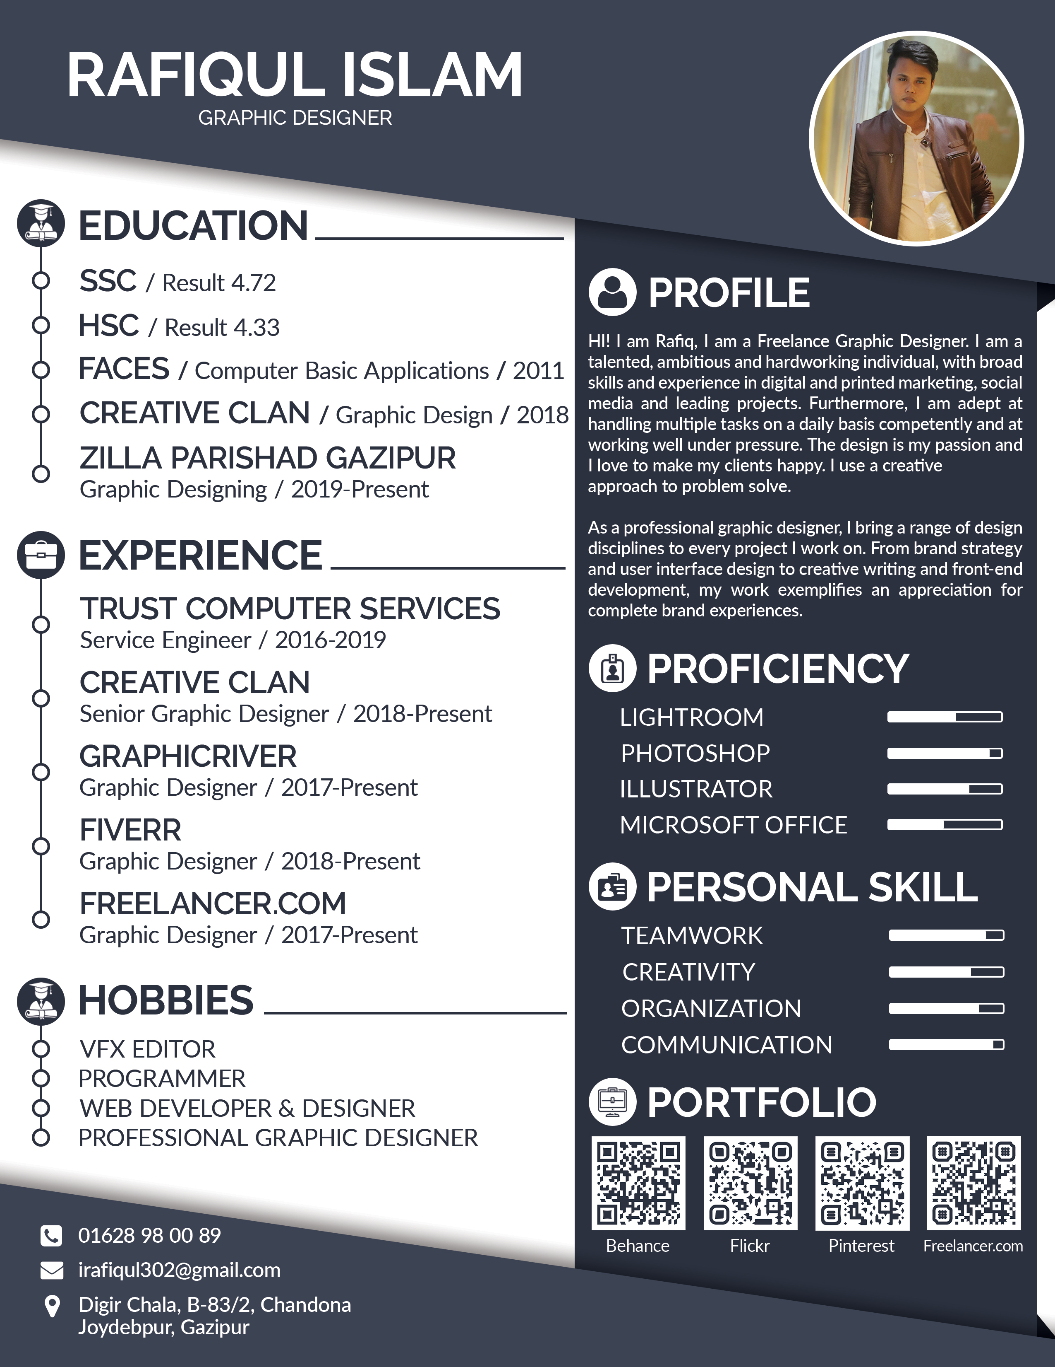

Visiting card

